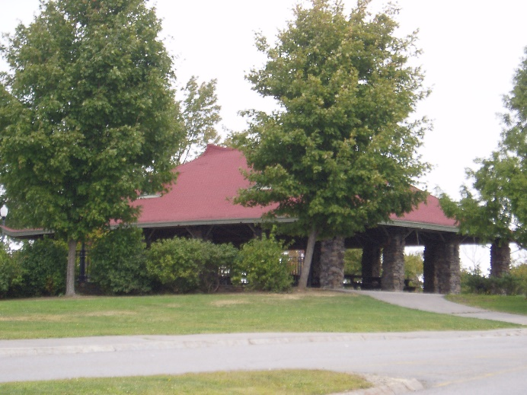
Green Hill Park Coalition
P.O. Box 323
Worcester, MA 01603
WWW.greenhillparkcoalition.org
Robert Antonelli, Jr.
Assistant Commissioner of Parks for the City of Worcester
A history of Green Hill Park in the city of Worcester, MA
Green Hill Park is Worcester's largest municipal park. It is over 480 acres and is host to a number of activities and facilities. It contains two ponds, a farm yard, picnic groves, playground, little league field, basketball courts, a refectory, golf course, many hiking trails and handball courts. It is also host to the Worcester Parks, Recreation and Cemetery administrative office.
Green Hill Park is located atop one of Worcester's seven main hills. It is bordered on the north by I-290, on the south by Route 9 (Belmont Street), on the west by Channing, Uxbridge and Denmark Streets (parallel to Lincoln Street), and to the east by Skyline Drive. Nearly 267 years ago the permanent settler to inhabit the hilly terrain of what is now Worcester's Green Hill Park began clearing a modest elevated site for his dwelling. An Englishman named Aaron Adams, one of the proprietors of the initial land grant, was the first of many generations to plan and manage the landscape of the park environs. Over the years, the Adams family, the Green Family, and the City of Worcester have managed the land, transforming the forested hills of Worcester to farmland, to a country estate and finally to a unique public park offering Worcester residents recreational opportunities that are rare in the urban setting.
In 1713 a group of settlers purchased eight square miles of hunting grounds, including the present parkland, from the Massachusetts Bay Colony. Aaron Adams of Sudbury, England was one of those settlers, and in the next five years he acquired two tracts of land totaling eighty-one acres. Adams built the first structure on the land in 1714, and established a farm on the northern section of Millstone Hill. Twenty years later more than a hundred acres adjacent to the farm was purchased for the town of Worcester's use as a quarry. By 1750, the only other addition to the land was seven acres bought at auction by Adam's brother Thomas, who then owned the farm.
In 1754, Dr. Thomas Green purchased from Thomas Adams about 180 acres. This land, with later additions, became known as "Stormont" or "Green Hill". His son, Dr. John Green inherited the land, and in 1757 he built the first Green family homestead.
By 1782, the Green landholdings had doubled to include the southern half of Millstone Hill. Upon John Green's death, the land went to his children, and in 1812, to one son in particular, William Elijah Green. John Green's children had significantly expanded and improved their landholding, having added fifty acres of the Crawford farm to the northeast of Millstone Hill and forming a small pond in the Bear Brook wetland (Green Hill pond is presently on this site). William continued to increase the size of the property by buying the northern half of Millstone Hill including the quarry, though a court decision determined that the public could still mine quarry stone there.
In 1848 William's son Andrew was given the family land, which then totaled 287 acres. Andrew Green was responsible for consolidating the family holdings by purchasing the remainder of the adjacent Crawford farm and discharging the family debts; he increased the size of the land by 312 acres to bring the total acreage of the land to more than twice its size 50 years before. It was during this period that the Greens' landholding was transformed from a country farm to a large estate. From his early life on the Worcester farm and later residence and deep commitment to the beautification of New York City, Andrew H. Green grew to be an eminent supporter of landscape gardening. In 1857, he became Commissioner of Central Park. His life was dedicated to improving the city dweller's quality of life through the development of parks and cultural institutions. This interest naturally was extended to his family estate and as his wealth increased, the grounds were enlarged and beautifully landscaped for the enjoyment of the Green family and their guests.
Andrew Green's influential life in New York brought him in contact with many people and places throughout the country. As gifts for his assistance and/ or hospitality, unusual ornamental trees and stone pieces were brought to the estate and placed on the grounds where they could be viewed and enjoyed. In 1850 Andrew Green divided in two (side by side) the original Family Homestead building, and built a new "mansion" in between, making 42 rooms in all. While farming was still pursued, grounds near the mansion were carefully planted and maintained as a rolling landscaped lawn sloping toward the lake waters.
In 1872, Andrew Green's brother Martin, who was trained as a civil engineer, came to reside at the estate as its manager. At the encouragement of his brother and on the merits of his professional background, he undertook many engineering and landscaping projects throughout the estate. Martin Green's decision in 1878 to dam the Bear Brook valley and form an extensive water body, (present day Green Hill Pond), greatly altered the character of the valley. The 30 acre pond provided pleasing vistas and opportunities for leisure and recreation where lawns, tree groves, and rocky outcroppings touched the shoreline.
Andrew Green died in 1903 and left his estate of 549 acres to five nieces and nephews, who in turn sold the parkland to the City of Worcester, contributing $50,000 towards a purchase price of $104,900. The park was officially transferred to the City on December 27th, 1905. By this purchase, the City of Worcester acquired a large and unique park resource which has since provided recreational opportunities for many generations of city residents.
Unique to this park, up until 1957 when it was demolished, was the Green family mansion. Beginning in 1906, two rooms were opened and utilized as “resting rooms” for women and children. A small room was utilized as a laboratory for students of our native birds and another room utilized by The Worcester Natural History Society as a lecture, assembly and meeting room. The largest daily mansion attendance that year was 912. Additionally in 1906 the Worcester City Missionary Society used two of the upper floors to provide a vacation spot for mothers with sick children and for others in need of convalescent care. Two large tents and the dairy portion of the Crawford Farm barn were used as a children’s hospital for approximately 60 patients that summer. Eventually, in 1957 after fifty-two years of public use, the wooden mansion was torn down; vandalism, damage from the hurricane of 1948, and high maintenance costs contributed to this decision
Important Dates for Green Hill Park.
December 27, 1905 the former Green Estate becomes Green Hill Park at a cost to the city of $54,900.00.
In 1911, the refectory (pavilion) is built at a cost of $2921.96.
In 1919 a 9 hole golf course is constructed at the present site of the “front 9”.
In 1927 a new bath house was constructed on the western shore of the large pond (current site of the 9th fairway). The cost was $5990.00 and it was constructed of cement block and stucco. In the same year a new golf clubhouse was built at the cost of $20,888.00. Preliminary work was begun on The Memorial Grove, a living monument to the citizens of Worcester killed in the Great War.
In May, 1928 The Memorial Grove is dedicated.
In 1929 a 16,000 square foot bowling green was opened adjacent to Lincoln Street (opposite the current site of Hanover Insurance) and was later replaced by a pool, basketball courts and archery practice area.
The original 9 hole golf course was rebuilt in April 1929.
In 1930 a new park entrance from Rodney Street was built. Additionally the “back 9” is added to the golf course making the course an 18 hole challenge.
In 1942 the Thomas Holland field house, built by the Works Progress Administration (WPA) is dedicated at the former site of the bowling green along Lincoln Street. It is called the Holland Recreation area. This site was used for a wading pond (Holland Rink), basketball courts, picnicking, Independence Day fireworks and an archery practice area.
In 1957, 7.24 acres of the highest land, at Millstone Hill, was transferred to the State for a National Guard Armory. A headquarters building, storage sheds and maintenance areas are constructed. A radar set was installed at the highest elevation.
In 1967, 4.47 acres of the park was taken by the state to construct I-290. The highway linked Worcester with east-west transportation corridors. This severed the Holland Recreation Area from the body of Green Hill Park, destroying its swimming pool and relegating the land to a neighborhood park with a ball field and basketball courts.
In 1968 the dump that for years was used both legally and illegally, located in the former quarry on Millstone hill, is ordered closed. For many years, after its usefulness had passed, the quarry on Millstone Hill was a problem that continually plagued the City officials. Clandestine dumping of refuse materials frequently occurred in the quarry cavity during the '40's and '50's. In the middle '60's, the City of Worcester used the quarry as a dump for building material refuse which was periodically burned, creating a pollution hazard in the northeastern section of the community. As neighborhood complaints grew more intense and State air pollution became more restrictive, the quarry dumping was suspended. The quarry site was again reopened in 1971 as a sanitary landfill managed by the City. In 1973 the landfill was completed, the site was graded and re-vegetated. This open grassy surface is now a park asset, available for use as a sports field.
In 1974 a refurbished Barnyard Zoo opened to visitors. The buffalo who used to roam in a spacious pen are gone from the scene.
December 2, 1976 the new Parks and Recreation Building located on the former site of the Green Mansion was dedicated. It was built at a cost of $80,000.00.
On June 8, 2002 the Massachusetts State Vietnam Memorial was dedicated. Also in June ground breaking for the Worcester Technical High School takes place on what was formerly park land. Additional acreage is added to the park to compensate for the land transfer.
Of the 110 years of public stewardship the City actively and creatively used the Green Hill Park resource for many varied uses, recreational programs and facilities. Some of programs and facilities included a toboggan run beginning at Crown Hill, an eighteen hole golf course and clubhouse, a bath house and beach, tennis courts, basketball courts, a community zoo and farm, bison and deer enclosures, a headquarters building, hiking, boating and swimming on Green Hill Pond, ice skating, The Massachusetts Vietnam War Memorial, Memorial Grove (WWI), a city street tree nursery, composting, community gardens, ball fields and tennis courts, the Forum Theater, the Holland Recreation area including an archery range, skating rink, field house and casting pool, and a health course with a series of exercise stations.
© 2015 | Copyright City of Worcester, MA | All Rights Reserved.
Additions to this document were made by the Green Hill Park Coalition, 2015

